



* *Student ID: 1429256 Student Name: M. Zorain Sharif*
* *Student ID:1429255 Student Name : Talha Karim*
* *Student ID:1351093 Student Name: Shahzain*

1





***M. Zorain Sharif***

***Talha Karim***

***Shahzain***

Signature

CERTIFICATE OF COMPLETION

Has successfully completed Course of Study

Date

Project Name

**Schools Info**

|  |  |  |
| --- | --- | --- |
| Faculty. | Miss Aeliya | |
| Batch. | PR-202211C | |
| Serial No. | Enrollment Number | Student Name |
| 1. | 1429256 | M.Zorain Sharif |
| 2. | 1429255 | Talha Karim |
| 3. | 1351093 | Shahzain |

EProject: SchoolsInfo

# ACKNOWLEDGEMENT

The first, we would like to express my special thanks of gratitude to my teacher Aaliya who helped us a lot in finalizing this project within the limited time frame, valuable counselling and assistance for the accomplishment of this project.

Secondly we would also like to thank the project team at Aptech Head Office, who gave us the golden opportunity to do this wonderful project about SchoolsInfo.

Thirdly, we also thank the project team, some of the benefits are as under:

* Re-enforcement of skills happens in the experiential learning process.
* A mentor, ensuring that we do not get drifted, constantly guides us.
* It gives us a lot of confidence to face an interview as we have worked on a project. We can explain virtually everything on the subject we have learnt.

EProject: SchoolsInfo

# SYNOPSIS

Follow the strong development of the internet and technology SchoolsInfo is the best platform to find suitable schools regarding to your requirements, every business needs a website design to display products on the internet.

In The following SchoolsInfo we try to cover different Schools, suitable for childrens and requirements, which are the most special suggestions from SchoolsInfo.

So SchoolsInfo shares the best schools images through the website for everyone to know.

However, admissions are not made directly on the website.

E-project:SchoolsInfo

# PROBLEM DEFINITION

SchoolsInfo is into business of showing the best schools in town. They have been advertising about their SchoolsInfo through newspapers, pamphlets, television. Now with changing times, they have decided to go online as parents today use Internet extensively. They have planned for a website with complete details about their SchoolsInfo.

So, we solved many particular queries as followed:

* How the sitemap possibly looks alike?
* What information should be displayed on each page?
* How to put every comment is friendly?
* How to give users the best experience when using the website?
* How to let the website properly functioning along with the system requirement?

E-project:SchoolsInfo

# REQUIREMENT SPECIFICATION (RS)

* **Requirement Specification:**

The Web site is to be created based on the following requirements.

1. The Home Page should be created making use of Sections with a suitable logo, the header section can be added which will show related images.
2. The site must contain the links to navigate through any category for the information.
3. The site should display a menu which will contain the options for brief introduction about the various schools , location and any other information if required.
4. The web site should also provide the option of searching the schools based on location and facilities.
5. Also have a Site Map option where viewers can see which all schools are available in our web site and can easily know where it is situated in the city. Their location should be displayed using GeoLocation API (eg. GoogleMaps)
6. The information about the school should include following major details

* + What is the maximum intake capacity of students?
  + Whether library is available
  + Availability of canteen facility
  + Availability of boarding
  + What type of sports options available

1. A brief summary of a particular school including list of facilities available, should be displayed on the Web Page along with the pictures but detailed features should be stored in individual Word documents which can be downloaded or viewed by the User who wishes to see the same.

E-project:SchoolsInfo

# SCOPE OF THE WORK (IN BRIEF)

The website is to be developed for the Windows Platform using HTML5, JavaScript and Geolocation. The site should work well in all leading browsers including Chrome, IE, Firefox etc.

Homepage show Top best schools, all facilities available, testimonials of visitors & their services. Every content direct to relative content.

E-project:SchoolsInfo

# AGGREGATED SITEMAP

**HH Home**

AHA,SDaxa,xzlaLAljLAD (0.Welcome.html)

cjua  **About**

skjsasadsassasaaWatches English

(1.Index.html)

E-project:SchoolsInfo



# WIREFRAMES



1. Main Layout

E-project:SchoolsInfo

1. Home Page (Index.html)

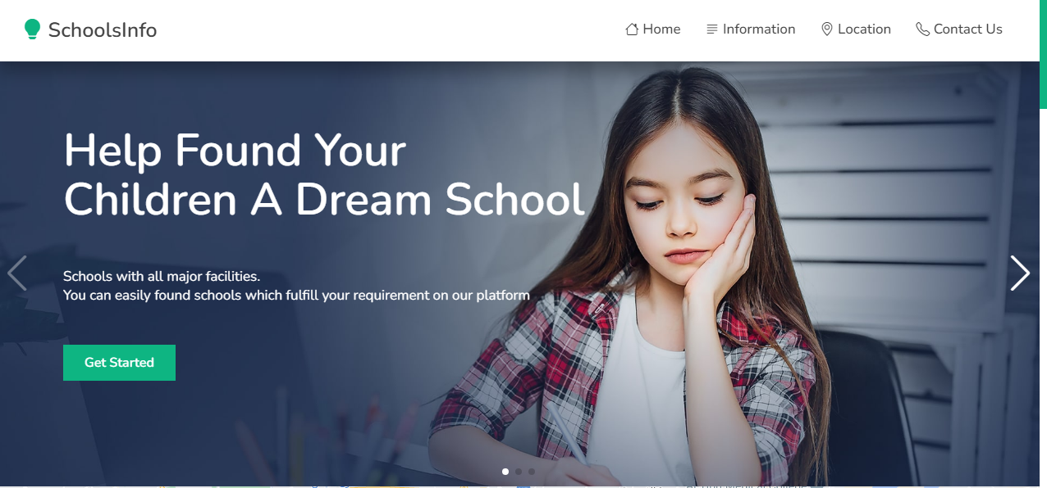

E-project:SchoolsInfo

1. Schools Informations Page (Information.html)

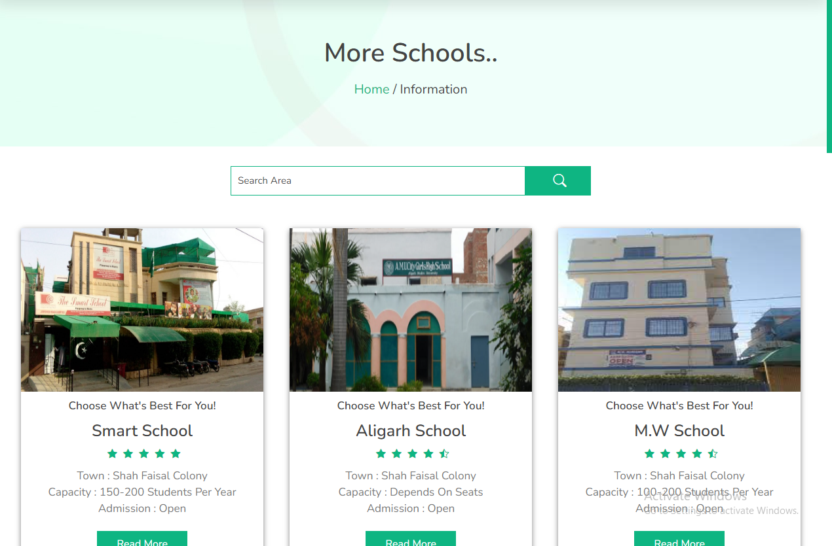

E-project:SchoolsInfo

1. Contact us page (contact.html)

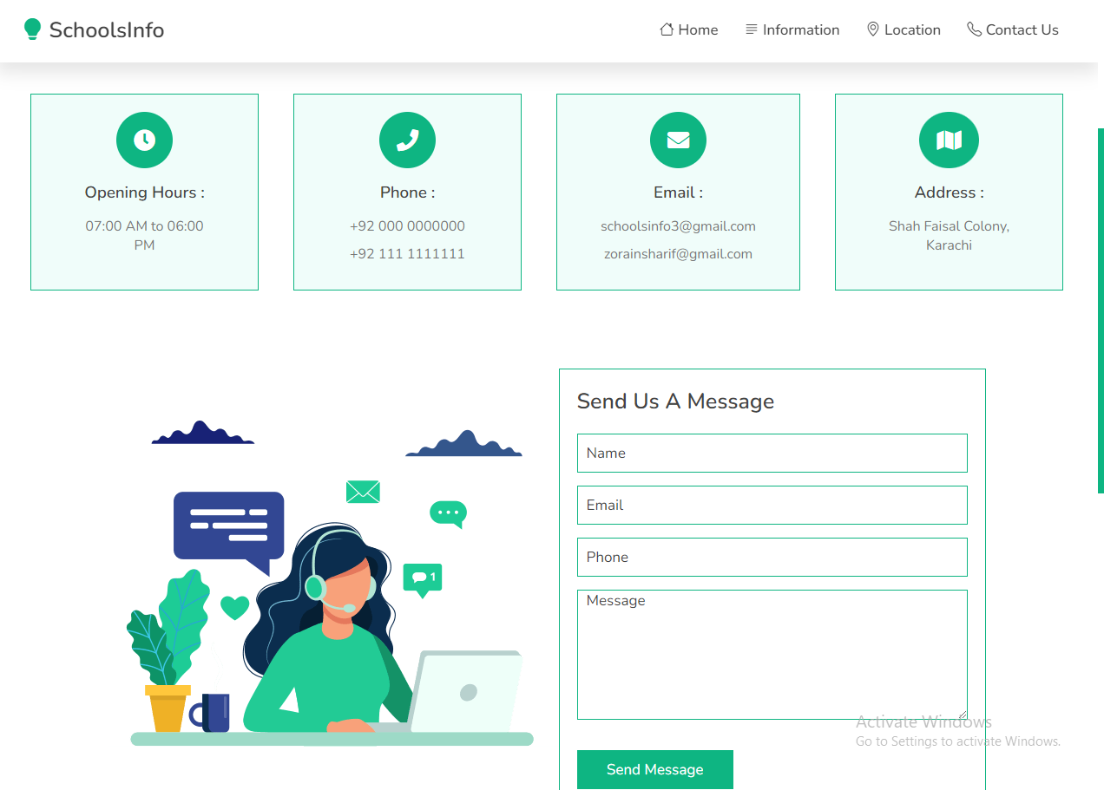

12

# TASK SHEET REVIEW 1

|  |  |  |  |  |  |  |
| --- | --- | --- | --- | --- | --- | --- |
| eProjects  Breakpoints | | Project title | Date of Preparation of Activity Plan | | | |
| No | Task |  | Actual | Actual | Team-mate | Status |
| Start Date | Days | Names |
| 1 | Build Home | 30/03/2023 | 1 | Student-1 | Complete |
| Page |
| 2 | Build contactus  page | 1/04/2023 | 3 | Student-2 | Complete |
| 3 | Build | 4/04/2023 | 2 | Student-2 | Complete |
| Information, Location, |
| Pages |
| 4 | Build Schools Pages | 6/04/2023 | 7 | Student-1 | Complete |
| 5 | Begin Code  Javascript For The Searchbar | 13/04/2023 | 5 | Student-1 | Complete |
| 6 | Begin Code | 18/04/2023 | 4 | Student-2 | Complete |
| Pages |

|  |  |  |  |  |  |  |
| --- | --- | --- | --- | --- | --- | --- |
| 8 | Begin Code Support For Browsers |  | 22/04/2023 | 1 | Student-1 | Complete |
| 9 | Check Progress And Assign New Tasks | 23/04/2023 | 1 | Student-1 | Complete |

# Thankyou.